**MODIFIED SIC PROJECT**

Reem Osama Hassan – Abdullah Yehia Awad

Our project takes Modi-Sic assembly code with line numbers and comments. The project is divided into four sections:

1. Generating intermediate file which create file in the form of table, without line numbers and comments leaving only the labels, instructions, and values.
2. Generating symbol table which defined a unique address for each symbol and detects symbol declaration errors (duplicate initialization of symbol).
3. Creating out_pass2 file that contains the addresses , labels, instructions, values, and object codes of each instruction. This files also handles special cases such as:
   * Array of words
   * Array of bytes
   * Array of bytes in hex
   * Array of characters
   * Immediate instructions (#)
   * Indexed instructions (,X)
4. Create HTE record file that takes for representing the whole program in a well defined way

Running process:

1. The input code must be put in file named “in.txt”
2. Run Modi SIC app
3. Close the app after it finishes

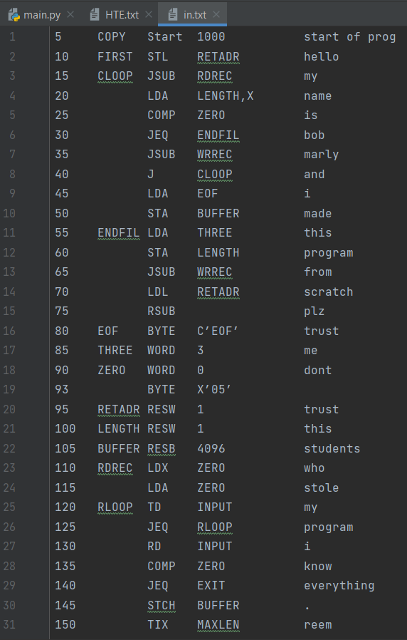

**In.txt**

Input file with line numbers and comments 😊

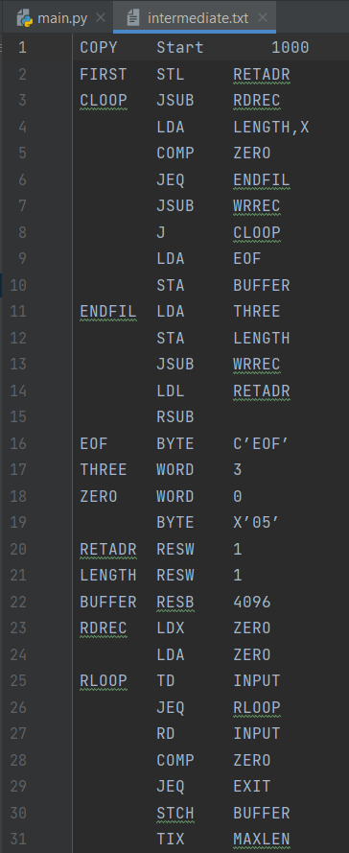

**Intermediate file symbol table**

**Output of pass1**

**Output of file 2**

**HTE record**